Bridge Priority Report Overview
In support of the Kentucky Transportation Cabinet (KYTC) Department of Rural and Municipal Aid County-City Bridge Improvement Program (CCBIP), the Department of Highways has provided Bridge Priority Reports (BPR) for local agencies. These reports summarize information for all locally owned bridges based on the National Bridge Inspection Standards (NBIS) Reports. Ratings use 1) Overall Bridge Condition, 2) Risk to the transportation network and 3) Mobility to assign a cumulative Priority Index (PI) score. Bridges are then assigned to three Project Tiers.
- Tier 1: Highest priority indicating significance due to bridge condition, transportation network risk and/or mobility.
- Tier 2: Medium priority indicating moderate condition, risk and mobility ratings, or a mix of high and low ratings for these factors.
- Tier 3: Low priority indicating low condition, risk or mobility concerns.
The Bridge Priority Report provides information to local agencies to understand locally owned bridges as part of a comprehensive Bridge Management Program. The overall goal of a Bridge Management Program should be to identify structures that are in need of 1) Cyclical and Condition Based Maintenance 2) repair and/or rehabilitation and 3) replacement. Specific maintenance and repair needs for each structure can be identified from a thorough review of the NBIS Inspection Reports provided by KYTC.
BPR Data Summary
This figure shows the fields that are contained in the BPR, which are discussed below. 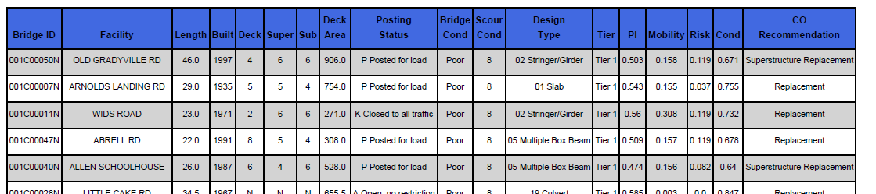

BPR Bridge Structure Data Fields
- Bridge ID-NBIS Structure ID.
- Facility- Name of Road facility is located on.
- Length- Bridge Length
- Built- Year Bridge was built
- Deck, Super, Sub- Condition rating of Deck, Superstructure and Substructure.
- Deck Area- Area of Bridge Deck
- Posting Status- Posting Status (Open-No Restrictions, Posted for Load, Closed to all Traffic)
- Bridge Condition- Determined by the lowest rating of the NBI conditions rating for Deck, Superstructure, Substructure. (Good (Rating ≥7, Fair 5-6, Poor ≤ 4).

- Scour Condition- Scour Condition Rating
- Design Type – Superstructure Bridge Design Type
- Tier – Maintenance Tier (Tier 1, Tier 2, Tier 3 described above
- PI – Priority Index Score (Rated from 0 (low priority) to 1 (highest priority)).
- Mobility, Risk, Condition- Mobility, Risk and Condition Scores based on NBIS Inspection Report.
- CO Recommendation- Maintenance Recommendations provided by KYTC Central Office. Note: The absence of Maintenance Recommendations does not indicate that no maintenance is required

